EDS Practical :05
Name: Vighnesh Pingle
PRN: 202501040449
Department: Computer Engineering Division: CS4
Batch: C45

5.1.1 Stacked plot Code:
import matplotlib.pyplot as plt import pandas as pd
# Data for Months and Temperature for three cities data = {
'Month': ['January', 'February', 'March', 'April', 'May',
'June', 'July', 'August', 'September', 'October', 'November', 'December'],
'City_A_Temperature': [5, 7, 10, 13, 17, 20, 22, 21, 18,
12, 8, 6],
'City_B_Temperature': [2, 3, 5, 6, 10, 14, 16, 17, 12, 9, 5,
3],
'City_C_Temperature': [3, 4, 6, 8, 9, 12, 15, 14, 10, 7, 4, 2]

}
# Write your code...
df = pd.DataFrame(data)
plt.stackplot(df['Month'],df['City_A_Temperature'],df['City_ B_Temperature'],df['City_C_Temperature'])
plt.xlabel('Month') plt.ylabel('Temperature') plt.title('Temperature Variation') plt.legend(loc='upper left') plt.show()
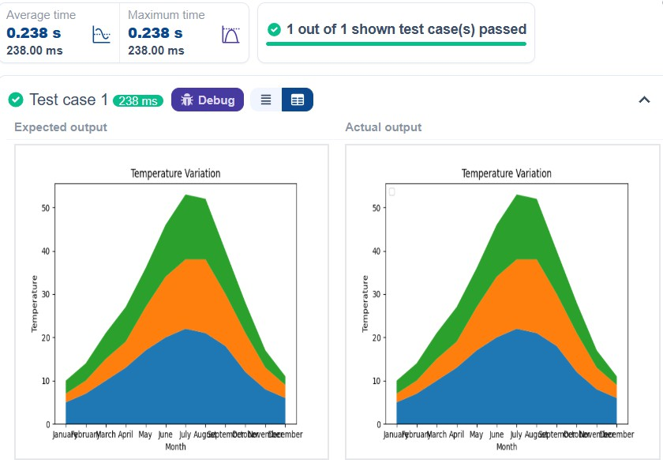

    - Titanic Dataset Code:
import pandas as pd
import matplotlib.pyplot as plt
# Load the Titanic dataset from the CSV ﬁle df = pd.read_csv('titanic.csv')
# Set up the ﬁgure for 5 subplots
ﬁg, axes = plt.subplots(3, 2, ﬁgsize=(12, 12)) # write the code..
##plot 1:count of passengers by class
axes[0, 0].bar(df['Pclass'].value_counts().index,df['Pclass'].value_ counts(), color='skyblue')
axes[0, 0].set_title("Passenger Class Distribution") axes[0,0].set_xlabel("Pclass") axes[0,0].set_ylabel("Count")
axes[0,1].pie(df['Gender'].value_counts(),labels=df['Gend er'].value_counts().index,autopct='%1.1f%
%',colors=['lightblue','lightcoral']) axes[0,1].set_title("Gender Distribution") #plot 3:Age distribution
axes[1,0].hist(df['Age'].dropna(),bins=8,color='lightgreen',

edgecolor='black') axes[1,0].set_title("Age Distribution") axes[1,0].set_xlabel("Age") axes[1,0].set_ylabel("Frequency") #plot 4:survival count
axes[1,1].bar(df['Survived'].value_counts().index,df['Survi ved'].value_counts(),color=['lightblue','lightcoral'])
axes[1,1].set_title("Survival Count")
axes[1,1].set_xlabel("Survived (0 = No, 1 = Yes)") axes[1,1].set_ylabel("Count")
#plot 5:fare vs age
axes[2,0].scatter(df['Age'],df['Fare'],color='orange',edgeco lors='black')
axes[2,0].set_title("Fare vs Age") axes[2,0].set_xlabel("Age") axes[2,0].set_ylabel("Fare") plt.tight_layout()
plt.show() Output:

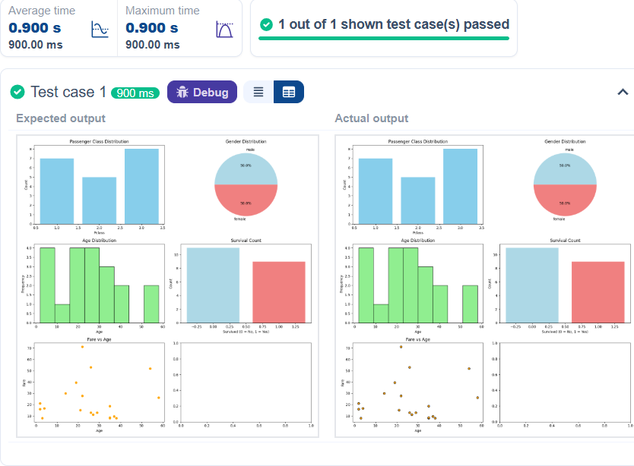

    - Histogram of Passenger information of Titanic Code:
#write your code here for histogram import pandas as pd
import matplotlib.pyplot as plt

# Load the Titanic dataset
data = pd.read_csv('Titanic-Dataset.csv') # Data Cleaning

data['Age'].ﬁllna(data['Age'].median(), inplace=True)
data['Embarked'].ﬁllna(data['Embarked'].mode()[0], inplace=True)
data.drop('Cabin', axis=1, inplace=True)
# Convert categorical features to numeric data['Sex'] = data['Sex'].map({'male': 0, 'female': 1})
data = pd.get_dummies(data, columns=['Embarked'], drop_ﬁrst=True)
# Write your code here for
# Write your code here for Histogram #write your code here for histogram plt.hist(data['Age'],bins=30,edgecolor='k') #plt.title('Age Distribution') plt.xlabel('Age')
plt.ylabel('Frequency') plt.title('Age Distribution') plt.show()
Output:

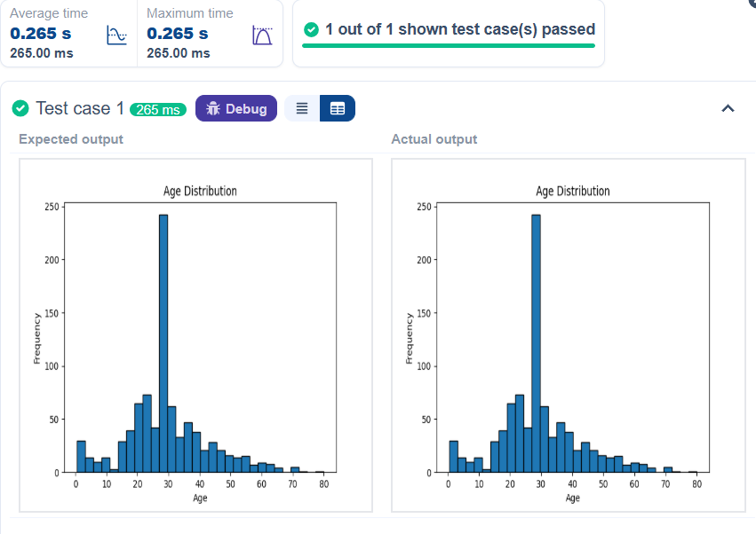

    - Bar plot of survival rate of passengers Code:
import pandas as pd
import matplotlib.pyplot as plt

# Load the Titanic dataset
data = pd.read_csv('Titanic-Dataset.csv') # Data Cleaning
data['Age'].ﬁllna(data['Age'].median(), inplace=True) data['Embarked'].ﬁllna(data['Embarked'].mode()[0],

inplace=True)
data.drop('Cabin', axis=1, inplace=True)
# Convert categorical features to numeric data['Sex'] = data['Sex'].map({'male': 0, 'female': 1})
data = pd.get_dummies(data, columns=['Embarked'], drop_ﬁrst=True)
# Write your code here for Bar Plot for Survival Rate survival_counts = data['Survived'].value_counts() survival_counts.plot(kind='bar')
plt.title('Survival Count') plt.xlabel('Survived') plt.ylabel('Count') plt.show()
Output:

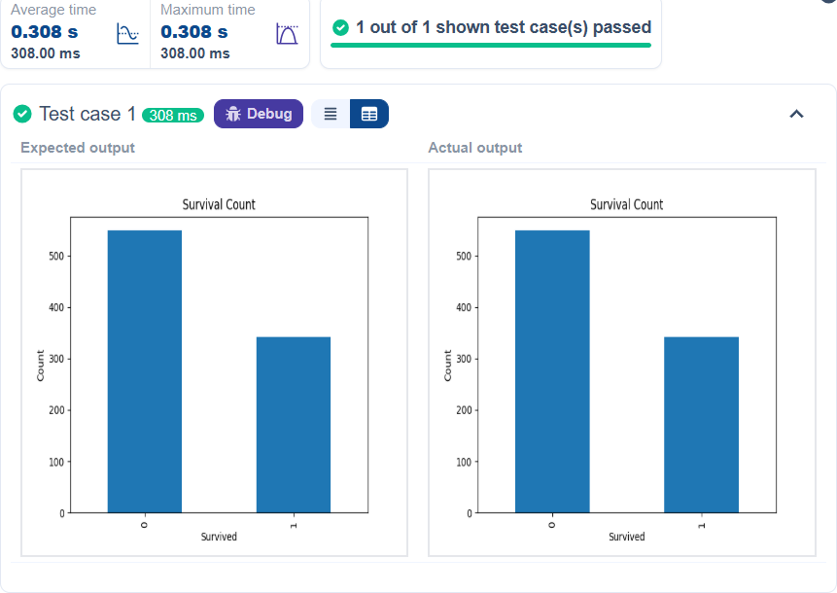

    - Bar plot for survival by Gender Code:
import pandas as pd
import matplotlib.pyplot as plt # Load the Titanic dataset
data = pd.read_csv('Titanic-Dataset.csv') # Data Cleaning
data['Age'].ﬁllna(data['Age'].median(), inplace=True)
data['Embarked'].ﬁllna(data['Embarked'].mode()[0], inplace=True)

data.drop('Cabin', axis=1, inplace=True)
# Convert categorical features to numeric data['Sex'] = data['Sex'].map({'male': 0, 'female': 1})
data = pd.get_dummies(data, columns=['Embarked'], drop_ﬁrst=True)
# Write your code here for Bar Plot for Survival by Gender
grouped=data.groupby('Sex') ['Survived'].value_counts().unstack()
grouped.plot (kind='bar', stacked=True) plt.title('Survival by Gender') plt.xlabel('Gender')
plt.ylabel('Count')
plt.legend(['Not Survived','Survived']) plt.show()
Output:

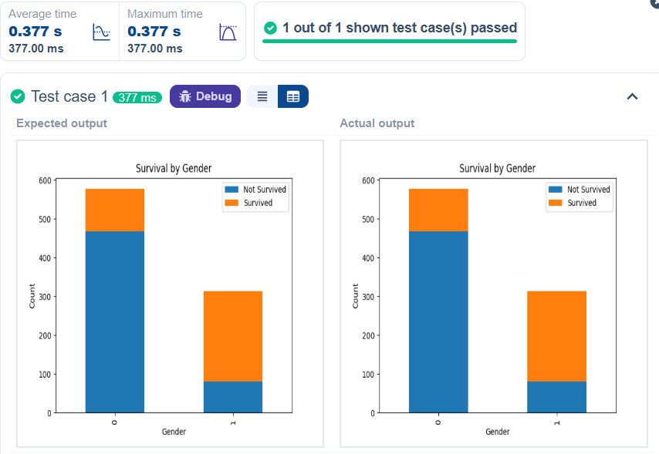

    - Bar plot for survival by Pclass Code:
import pandas as pd
import matplotlib.pyplot as plt # Load the Titanic dataset
data = pd.read_csv('Titanic-Dataset.csv') # Data Cleaning
data['Age'].ﬁllna(data['Age'].median(), inplace=True)
data['Embarked'].ﬁllna(data['Embarked'].mode()[0], inplace=True)
data.drop('Cabin', axis=1, inplace=True)

# Convert categorical features to numeric data['Sex'] = data['Sex'].map({'male': 0, 'female': 1})
data = pd.get_dummies(data, columns=['Embarked'], drop_ﬁrst=True)
# Write your code here for Bar Plot for Survival by Pclass
survival_counts = data.groupby('Pclass') ['Survived'].value_counts().unstack()
survival_counts.plot(kind='bar',stacked=True) plt.title('Survival by Pclass') plt.ylabel('Count')
plt.legend(['Not Survived','Survived']) plt.show()
Output

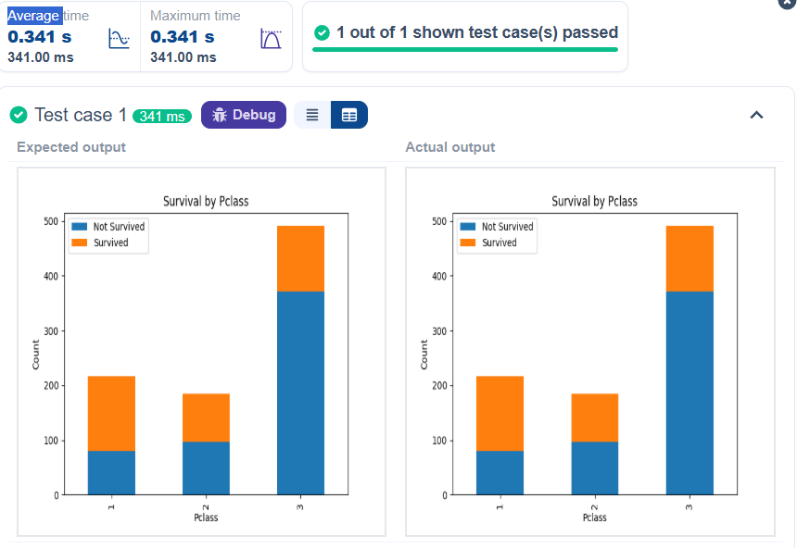

    - Bar plot for survival by Embarked Code:
import pandas as pd
import matplotlib.pyplot as plt # Load the Titanic dataset
data = pd.read_csv('Titanic-Dataset.csv') # Data Cleaning
data['Age'].ﬁllna(data['Age'].median(), inplace=True)
data['Embarked'].ﬁllna(data['Embarked'].mode()[0], inplace=True)
data.drop('Cabin', axis=1, inplace=True)

# Convert categorical features to numeric data['Sex'] = data['Sex'].map({'male': 0, 'female': 1})
data = pd.get_dummies(data, columns=['Embarked'], drop_ﬁrst=True)
# Write your code here for Bar Plot for Survival by Embarked
survival_counts = data.groupby('Embarked_Q') ['Survived'].value_counts().unstack()
survival_counts.plot(kind='bar',stacked=True) plt.title('Survival by Embarked') plt.xlabel('Embarked')
plt.ylabel('Count')
plt.legend(['Not Survived','Survived']) plt.show()
Output:

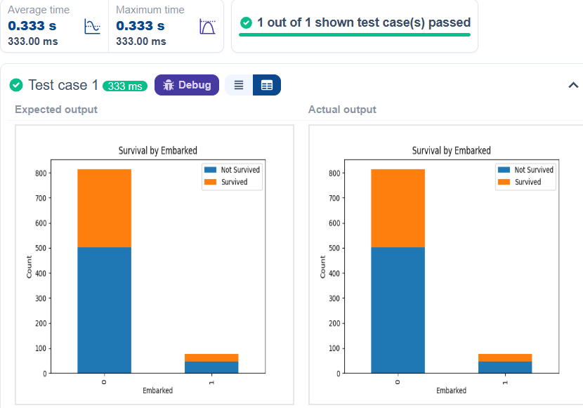

    - Box plot for Age Distribution Code:
import pandas as pd
import matplotlib.pyplot as plt # Load the Titanic dataset
data = pd.read_csv('Titanic-Dataset.csv') # Data Cleaning
data['Age'].ﬁllna(data['Age'].median(), inplace=True)
data['Embarked'].ﬁllna(data['Embarked'].mode()[0], inplace=True)
data.drop('Cabin', axis=1, inplace=True)

# Convert categorical features to numeric data['Sex'] = data['Sex'].map({'male': 0, 'female': 1})
data = pd.get_dummies(data, columns=['Embarked'], drop_ﬁrst=True)
# Write your code here for Box Plot for Age by Pclass data.boxplot(column='Age',by='Pclass')
plt.title('Age by Pclass') plt.xlabel('Pclass') plt.ylabel('Age') plt.suptitle("") plt.show()
Output:

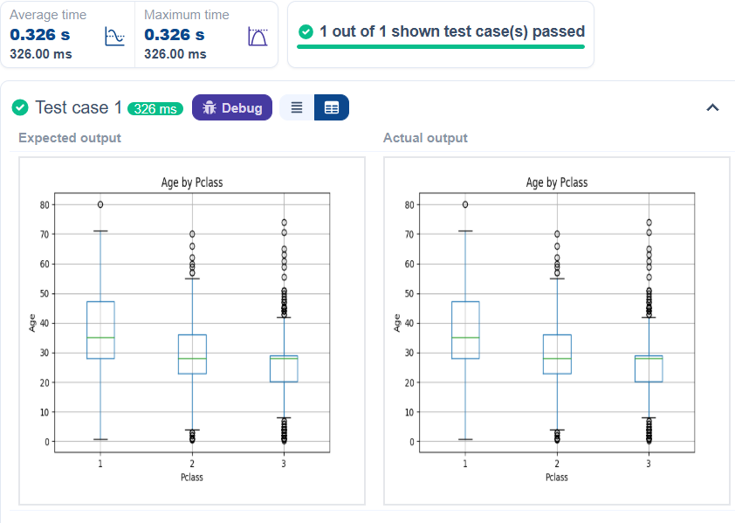
    - Box plot for Age by Survived Code:
import pandas as pd
import matplotlib.pyplot as plt # Load the Titanic dataset
data = pd.read_csv('Titanic-Dataset.csv') # Data Cleaning
data['Age'].ﬁllna(data['Age'].median(), inplace=True)
data['Embarked'].ﬁllna(data['Embarked'].mode()[0], inplace=True)
data.drop('Cabin', axis=1, inplace=True)

# Convert categorical features to numeric data['Sex'] = data['Sex'].map({'male': 0, 'female': 1})
data = pd.get_dummies(data, columns=['Embarked'], drop_ﬁrst=True)
# Write your code here for Box Plot for Age by Survived data.boxplot(column='Age',by='Survived')
plt.title('Age by Survival') plt.xlabel('Survived') plt.ylabel('Age') plt.suptitle("")
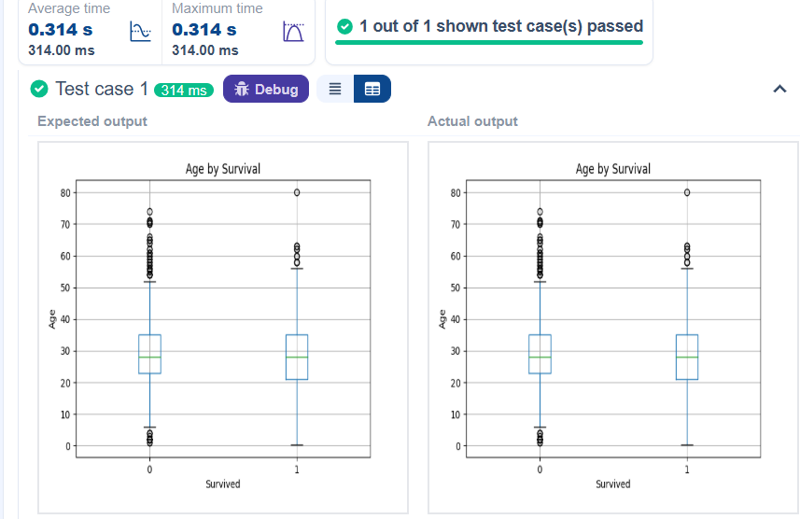
plt.show() Output:

    - Box plot for fare by Pclass Code:
import pandas as pd
import matplotlib.pyplot as plt # Load the Titanic dataset
data = pd.read_csv('Titanic-Dataset.csv') # Data Cleaning
data['Age'].ﬁllna(data['Age'].median(), inplace=True)
data['Embarked'].ﬁllna(data['Embarked'].mode()[0], inplace=True)
data.drop('Cabin', axis=1, inplace=True)
# Convert categorical features to numeric data['Sex'] = data['Sex'].map({'male': 0, 'female': 1})
data = pd.get_dummies(data, columns=['Embarked'], drop_ﬁrst=True)
# Write your code here for Box Plot for Fare by Pclass data.boxplot(column='Fare',by='Pclass')
plt.title('Fare by Pclass') plt.suptitle( ') plt.xlabel('Pclass') plt.ylabel('Fare')

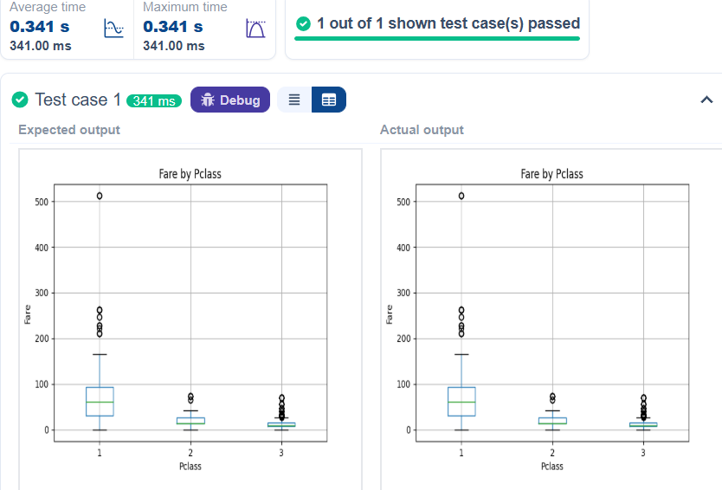
plt.show() Output:

    - Scatter plot for Age vs Fare Code:
import pandas as pd
import matplotlib.pyplot as plt # Load the Titanic dataset
data = pd.read_csv('Titanic-Dataset.csv') # Data Cleaning
data['Age'].ﬁllna(data['Age'].median(), inplace=True) data['Embarked'].ﬁllna(data['Embarked'].mode()[0],

inplace=True)
data.drop('Cabin', axis=1, inplace=True)
# Convert categorical features to numeric data['Sex'] = data['Sex'].map({'male': 0, 'female': 1})
data = pd.get_dummies(data, columns=['Embarked'], drop_ﬁrst=True)
# Write your code here for Box Plot for Fare by Pclass plt.scatter(data['Age'],data['Fare'])
plt.title("Age vs. Fare") plt.xlabel("Age") plt.ylabel("Fare") plt.show()
Output:

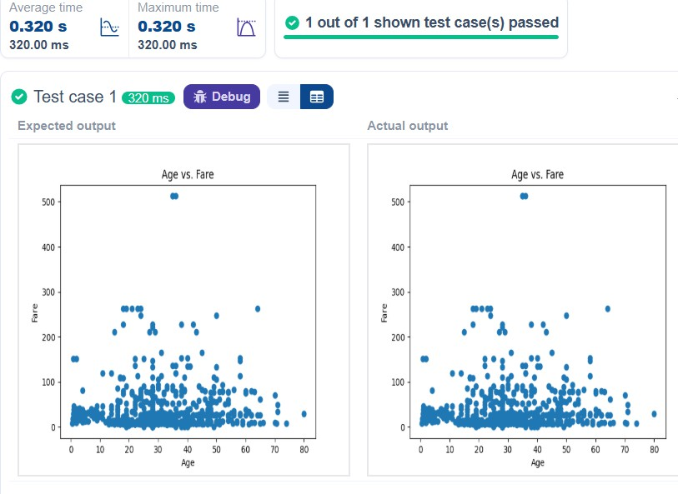

    - Scatter plot for Age vs Fare by Survived Code:
import pandas as pd
import matplotlib.pyplot as plt # Load the Titanic dataset
data = pd.read_csv('Titanic-Dataset.csv') # Data Cleaning
data['Age'].ﬁllna(data['Age'].median(), inplace=True)
data['Embarked'].ﬁllna(data['Embarked'].mode()[0], inplace=True)
data.drop('Cabin', axis=1, inplace=True)

# Convert categorical features to numeric data['Sex'] = data['Sex'].map({'male': 0, 'female': 1})
data = pd.get_dummies(data, columns=['Embarked'], drop_ﬁrst=True)
# Write your code here for Scatter Plot for Age vs. Fare by Survived
colours=data['Survived'].map({0: 'red',1: 'blue'}) plt.scatter(data['Age'],data['Fare'],c=colours) plt.title("Age vs. Fare by Survival") plt.xlabel("Age")
plt.ylabel('Fare') plt.show() Output:

L
_J
Average time |  | Maximum time
0.299s  299.00 ms | � | 0.299s  299.00 ms

tn: O 1 out of 1 shown test case(s) passed

0 Test case 1 fi.MHoi¥t I,l·ffi·hi - D A
Expected output Actual output
•
...,,. .•, •
•

500
•
....,,. .•, •
•

400

300

,oo

100
Age vs. Fare by Survival

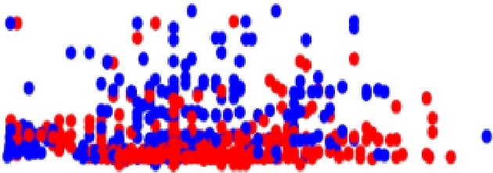
,oo

100
Age vs. Fare by Survival

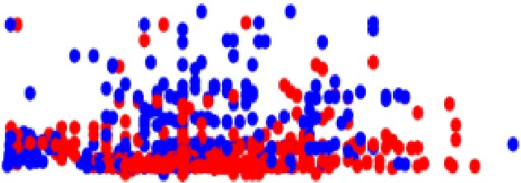

0 | W | W | � | 40 | 50 | 00 | M | 00 | 0 | W | W | � | 40 | 50 | 00 | M | 00
 |  |  |  | Age |  |  |  |  |  |  |  |  | Age

7

